

**PBL Project Phase # 2**

CMPS405

Eng. Heba Dawoud

**Socket Programming**

December 1st, 2024

**Students:**

Fatima Almohanadi 202002307

Shatha Alhazbi 202108114

Reema Albouainain 202103056

Link to GitHub Repository for Project: <https://github.com/shatha-sa2108114/OS-Project>

**Introduction:**

This report documents the successful completion of Phase 1 & Phase 2 of the Operating Systems (PBL) project. In phase1, Our team has developed a series of shell scripts to address the challenges of automating network administration tasks in a virtual machine (VM) environment. This project provided practical experience in server and client configuration, security implementation, network services automation, and problem-solving using shell scripting. The project focused on creating a robust and secure network environment of one server (VM1) and two clients (VM2, VM3). In phase 2, we implimented a multithreaded client-server application using Java, building upon Phase 1. The system consists of three main components: server, client1, and client2.

**Table of Contents:**

|  |  |
| --- | --- |
| Title | 1 |
| Introduction | 2 |
| Screenshots | 3 |
| Task Distribution | 3 |
| Conclusion | 3 |

**Screen Shots:**

1. Server terminal: traceroute.sh & system.sh & network.sh

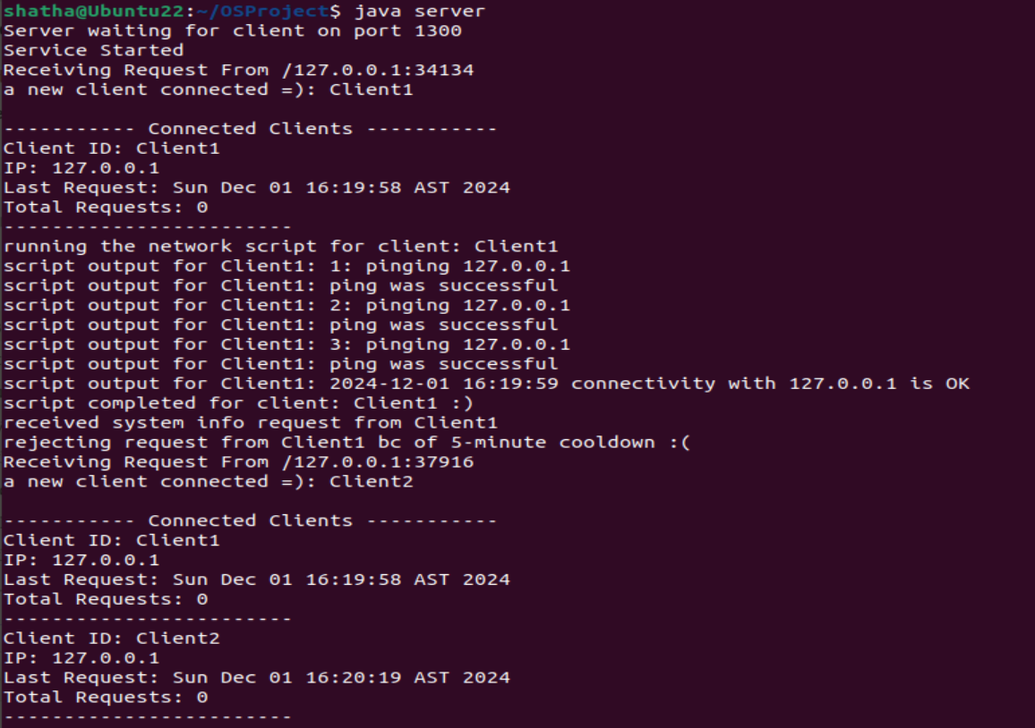

1. After sending to both clients

1. After more requests

1. Client 1 terminal: login.sh & check.sh

1. Client 2 Terminal: clientinfo.sh & search.sh

**Task Distribution:**

|  |  |  |
| --- | --- | --- |
| Student | Tasks | Percentage |
| Shatha | * Server VM * Network.sh * Traceroute.sh * System.sh | 33% |
| Fatma | * Client 1 * Login.sh * Check.sh | 33% |
| Reema | * Client 2 * Search.sh * Clientinfo.sh | 33% |

Even though each member had a specific task, we maintained a collaborative spirit throughout the project. We had regular meetings where we solved the tasks together, shared our progress, brainstormed solutions to challenges, and reviewed each others work. Each member contributed meaningfully and equally to the final outcome. In phase 1 we each worked on separate machines.

For Phase 2, we worked only on Shatha’s machine. we ran client 1,2 and server all on Shatha’s Laptop. We met on teams and solved the problems together.

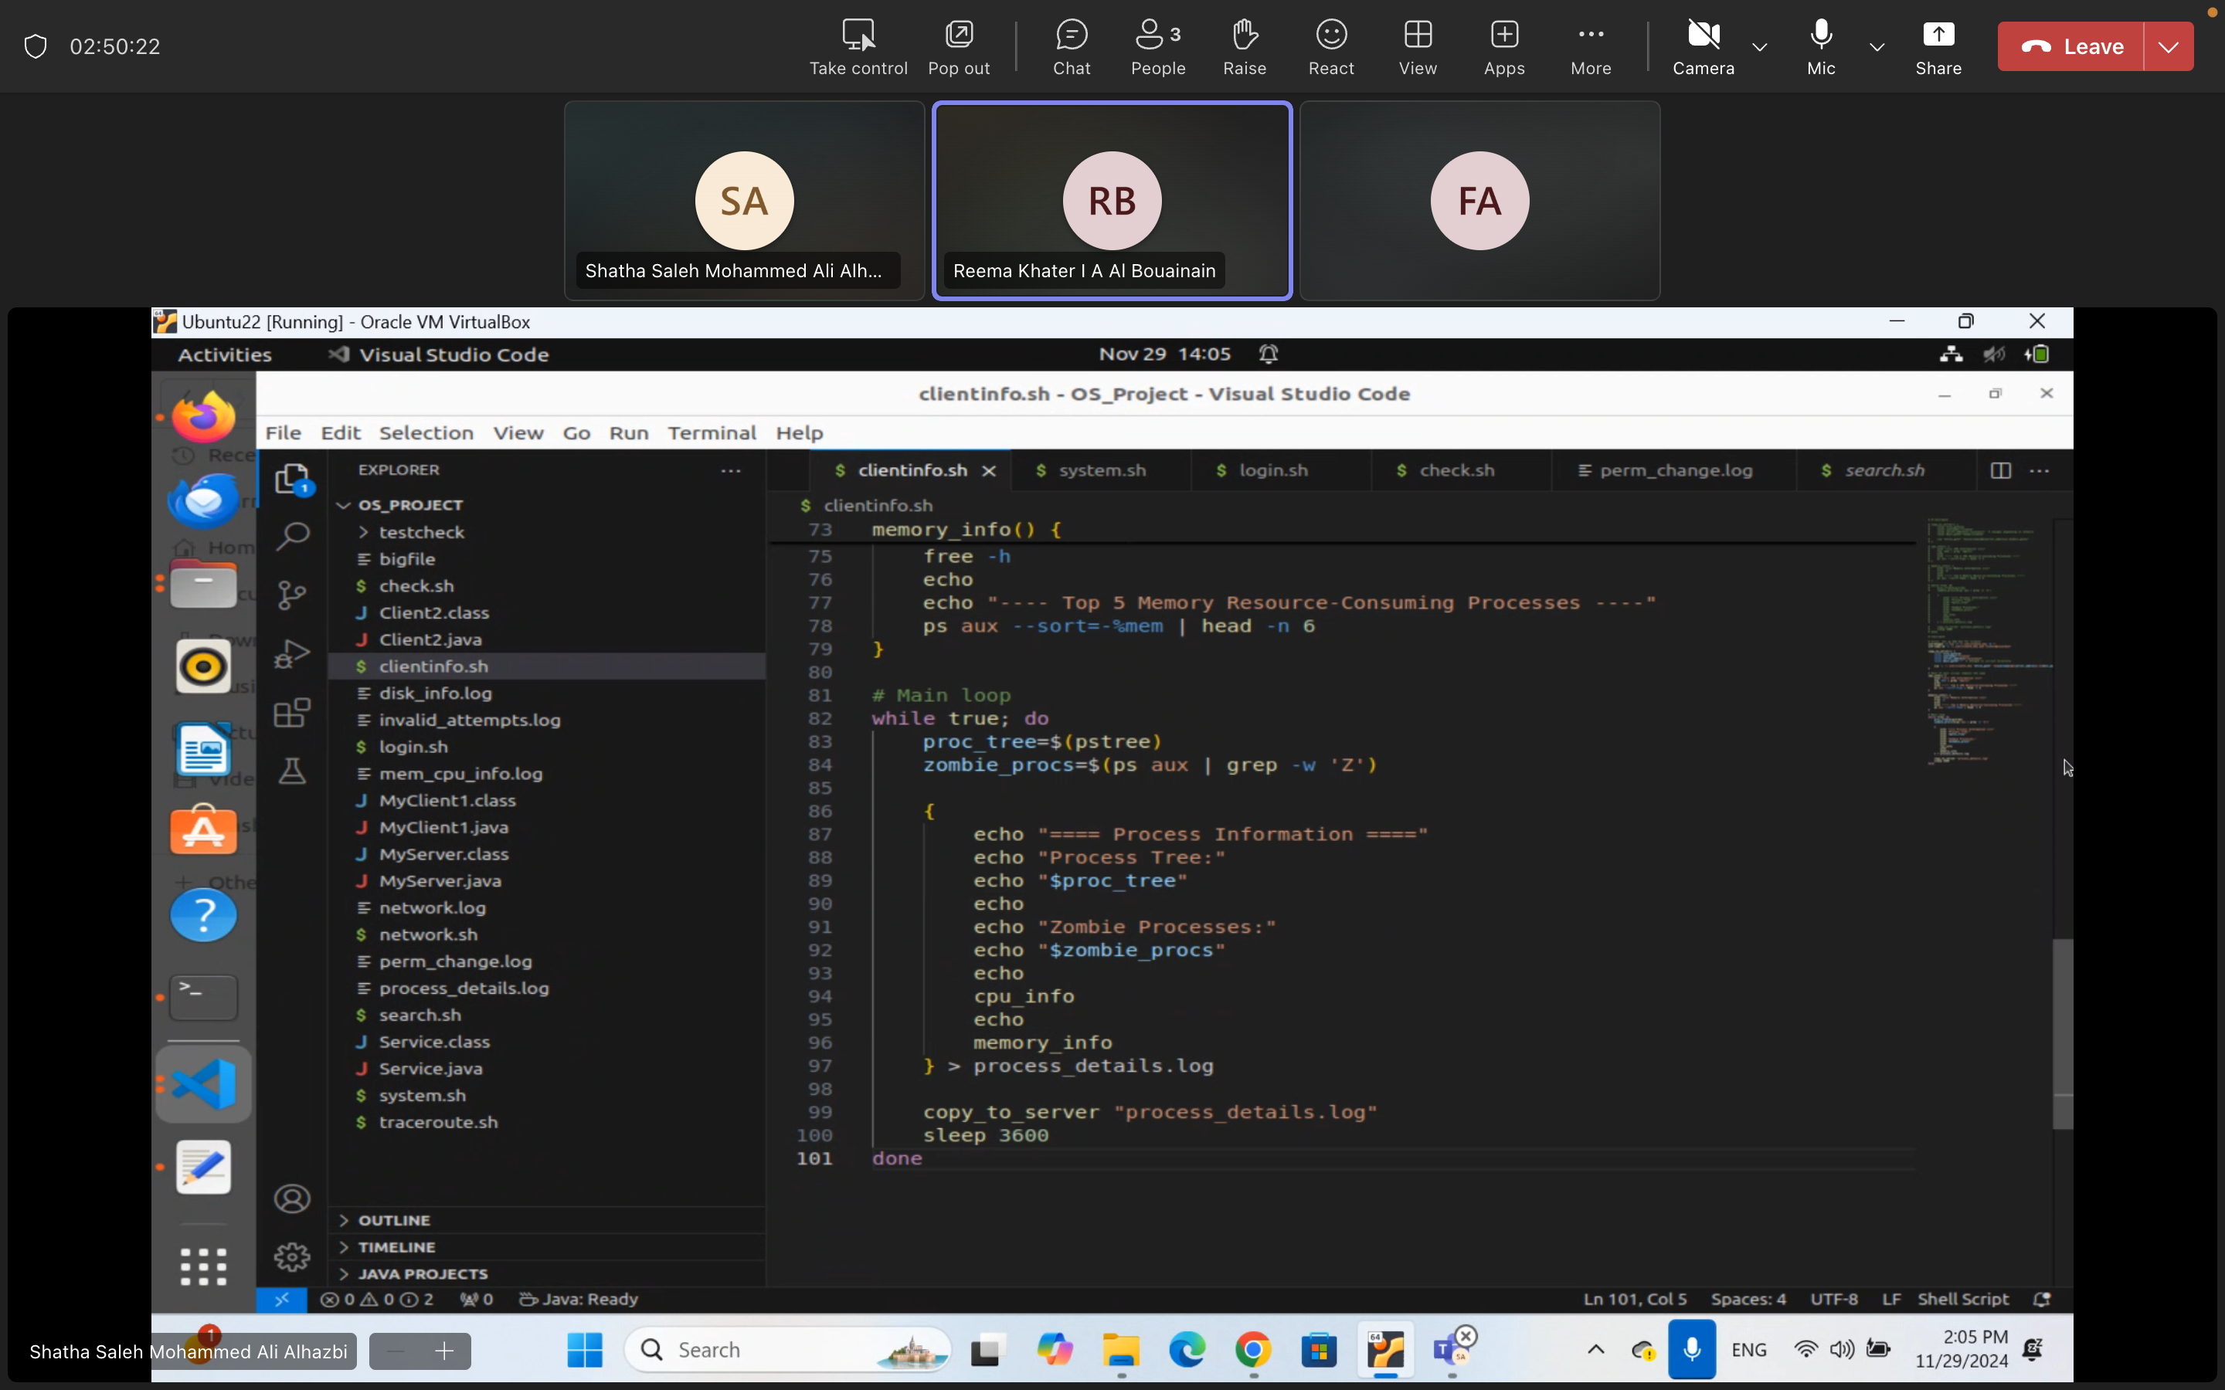

**Conclusion:**

Upon completing the project, we have faced a few challenges like file transfer, synchronization issues, and the integration of our shell scripts. Through teamwork, we managed to solve these issues with proper research. These are the challenges and how we solved them:

1. Thread Synchronization for System info Requests

Responding to system info requests from multiple clients was risk of race condition, we needed to prevent multiple clients from executing system.sh simultaneously. Therefore, we implemented static synch lock object and synchronized the critical section. Also, we used Collections.synchronizedList for client tracking

2. File Transfer Management

We needed to find a way to get file transferred out of server to clients in reliable manner while also handling any errors. To solve this, we used buffered streams, and added error handing.

3. Executing shell scripts

We needed to find a way to run shell scripts from java. We solved this by using ProcessBuilder, and used strean handling for output capture. We also made sure to handle any errors

Finally, Our team learned a lot from this project, and we had a lot of fun collaborating together. We are confident in our abilities to solve future projects together ☺